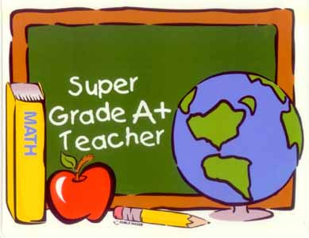
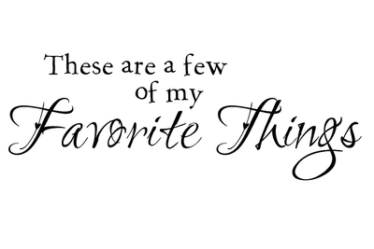
Fast Food: Chick Fi La
Restaurants: Firebirds and Bonefish
Drinks: coke and water
Stores: Dillard’s and Amazon
Color: North Carolina Blue
Sweets: Nothing Bundt Cake (lemon) and snickers
Crunch: Simply Cheetos White Cheddar
Team: Dallas Cowboys

